
THE QUEEN’S OWN CAMERON HIGHLANDERS OF CANADA
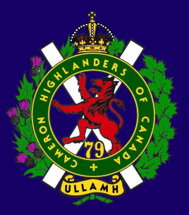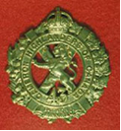
THE CAMERON ASSOCIATION IN CANADA
THE QUEEN’S OWN CAMERON HIGHLANDERS OF CANADA
MINTO ARMOURY, 969 ST. MATTHEWS AVE WPG, MB R3G 0J7
STILL WINNIPEG'S ONLY HIGHLAND REGIMENT !
2017/2018 ASSOCIATION OFFICERS
PRESIDENT | Steve MacMillan | 351 Ainslie St  Wpg, MB R3J 2Z7 | sdmacmillan@shaw.ca | 204-831-0542
VICE-PRES | Fred Westphal |  | fwestphal1286@gmail.com | 204-296-7656
SECRETARY | Hugh O’Donnell | 713 Cambridge St Wpg, MB R3M 3G2 | hodonnell@draega.net | 204-285-7222
TREASURER | Dave Gibson | 104 William Gibson Bay Wpg, MB R3C 5L7 | dwgibson@mymts.net | 204-222-9509
2016/17 aSSOCIATION Executive Board
Past Pres | Taffy Gray | 198 Seekings St Headingly, MB R4J 1B1 |  | 204-889-5655
Special Projects and Recruiting Director | Steve Smith | TBC | TBC | TBC
Sick, Visiting, and Last Post Director | Len Johnson | 1094 Bay Rd  St. Andrews, MB R1A 3L1 |  | 204-757-2023
Foundation Trustees |  | Blair Will  (2017-2019) | Marc Gautron  (2016-2018)

* Last Post *
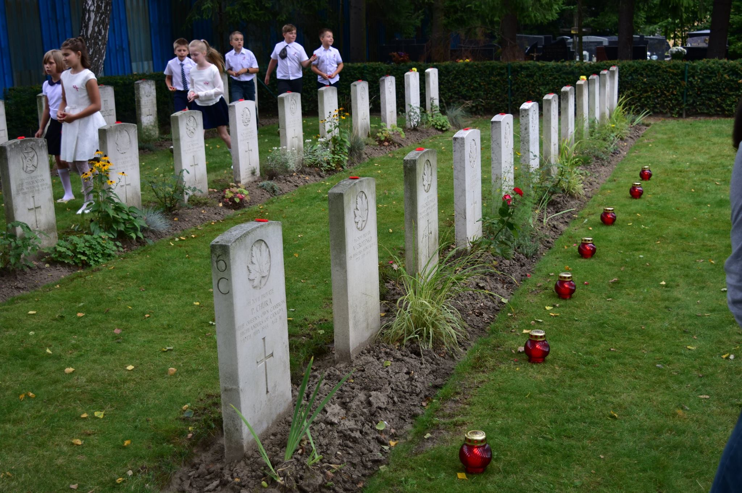
Polish students help to mark Canadian headstones
Pte Philip Chura,
Camerons of Canada is buried under headstone 6C
Rakowicki Cemetery , Poland
AGNES (BUNTY) MARY BEATTIE
(Former Cold War Cameron P/M Sandy Beattie's widow)
http://passages.winnipegfreepress.com/passage-details/id-245934/BEATTIE_AGNES
On Friday, May 12, 2017, Bunty passed away peacefully at Golden West Centennial Lodge, at the age of 87 years. Remaining to cherish Bunty's memory are her daughter Anne Gray (Mark); and grandchildren as well as her great-granddaughter Bodhi. In Scotland she leaves one sister and one brother. On April 6, 1930, Bunty was born in Aberdeen, Scotland, the oldest of 14 children. She married Alexander (Sandy) Beattie in 1952 and their daughter Anne was born in 1953. The family immigrated to Canada in 1957 and settled in Winnipeg. After Anne left home, Bunty and Sandy moved to Carman where Bunty remained until returning to Winnipeg in 1999. Bunty was a true Scot and returned to Scotland many times to visit family.
A private family gathering was held. In lieu of flowers, donations may still be made to the Salvation Army Golden West Centennial Lodge, 811 School Road, Winnipeg, MB R2Y 0S8. Wojcik's Funeral Chapels & Crematoriums, Winnipeg, 2157 Portage Avenue, 204.897.4665 www.wojciksfuneralchapel.com
Full obit published in the Winnipeg Free Press on May 20, 2017
PIPE-MAJOR DONALD ALEXANDER MORRISON (Cold War)
http://passages.winnipegfreepress.com/passage-details/id-249525/MORRISON_DONALD
November 15, 1926 October 8, 2017 Peacefully, Donald Morrison slipped away in the early morning, surrounded by his family. In the course of almost 91 years, Don touched a great many lives with his laughter, charisma, musicianship and wisdom. He is survived by the love of his life, wife Rose; daughters, Catherine (Howard), Carolyn, Colleen (Mark); son Colin; special niece Sandi Mitchell and numerous other nieces, nephews and grandchildren.
Don grew up in the West End of Winnipeg and, with his father a teamster, had a lifelong fondness for the "heavy" horses. Losing his father in a tragic accident at age 12, Don had to grow up early as the family struggled in the hard times of the Depression. His father had started teaching him the Highland bagpipes at age nine, and this would be one of the defining aspects of Don's life. He began playing with the Cameron Cadet Pipe Band even prior to reaching the minimum age for joining (12), and played with them until he was 19, leaving as Pipe Major.
Piping, Minto Armouries and his Cameron buddies were the formative influences in his adolescence. He joined the Queen's Own Cameron Highlanders Reserve as a 17 year old and maintained a life-long association with the Camerons and their Pipe Band. In 1947, he joined the Winnipeg Police Force and immediately joined the Police Pipe Band. Don went on to be a member of the Police Force for 39 and one half years (retiring as Acting Superintendent) and incredibly, a member of the Pipe Band for 53 years (18 years as Pipe Major).
During his busy years as a police officer and as a member of the Police Pipe Band, Don was also father to a young family. He juggled shift work, piping and home commitments, all while serving as the band instructor of the Cameron Cadet Pipe Band, a position he held for 20 years (retiring as a Captain in the Reserve Army). Piping and drumming lessons were delivered in his home basement to anyone with an interest and willing to practice free of charge.
Don believed in passing on the craft, as he himself had been the beneficiary of legendary instructors such as Doug Will and Sandy Cameron, and many former students became his fellow band members. Long before trips for young people became somewhat routine, Don took his Cadet Band to Texas to compete, even supervising Grade 12 Departmental examinations en route so everyone could attend. The Band did well, achieving international honours and Don, competing individually, won the North American competition. At the same time, the Police Pipe Band was one of the finest Pipe Bands in North America and travelled extensively throughout the Continent.
In 1960, Don was chosen as the solo piper accompanying the Pine to Palm Tour, a three bus campaign comprised of prominent politicians, business owners, and press promoting tourism and commerce along the route from Winnipeg to New Orleans. This culminated with Don being made an honorary citizen of New Orleans. Don was selected as Pipe Major of a Massed Military Band comprised of Reserve Army and Cadet Band members that played at the Hemisfair in San Antone, Texas. He was Pipe Major of the 200 member Massed Pipe and Drum Band of Winnipeg for the Rose Bowl Parade in Pasadena. Don was also the designated piper for innumerable official functions and played for Queen Elizabeth, Princess Margaret, Lieutenant Governors, Prime Ministers, Provincial Premiers and Mayors.
He also played at the Dieppe Reunion in France in 1983, after which he was able to visit his brother Colin's grave in Sage, Germany, where Colin had been shot down in one of the last raids of the Second World War. His enthusiasm never waned and in 1992 he founded the ANAVET #283 Legion Pipe Band, which continues on to this day. Don continued playing and in his last competition in 1993 at 66 years of age, he took 1st prize in the Masters category at the Fergus Highland Games.
To put those achievements in perspective however, a listing of Don's many other awards and acknowledgments is required. Don was also intensely interested in politics and history and virtually never missed a day reading the newspaper or watching the news on television. He was an avid reader and, until just a couple of weeks ago, was still reading three to four books weekly. He could equally discuss the antecedents of the First World War or the re-opening of Portage and Main!
There was another side of him too though, and this was his humanity something almost palpable you could feel when you were with him. He loved his family, taking pride in their achievements and development as they became young adults. That warmth extended too to animals, and he loved his dogs. While slightly cynical, as you might expect after 39 plus years as a police officer, he never lost a belief in the basic goodness of people, nor indeed in the greatness of this city, province and country, though the Winnipeg Jets did vex him from time to time. Don was intensely proud of his Scottish heritage, but equally proud to be Canadian. He left as a proud Scot and a true Canadian. A Celebration of Life was be held on Saturday, October 14 at 1:00 p.m. in the First Presbyterian Church, 61 Picardy Pl. (Portage Ave. and Canora - east of Vimy Ridge Park).
Full obit published in the Winnipeg Free Press on Oct 13, 2017
Editor's note: Yet again this year another Cameron legend has passed on and his celebration of life was just that. The massed bands of the Camerons, the Winnipeg Police (and I think I saw more than a few #283 ANAF members in the mix too) were simply magnificent. I have no idea when First Prebyterian last saw so many pipers of such high caliber present, but from Lord Lovat's Lament to Highland Cathedral those playing sent Donny off in style. I'm pretty certain that Monty and Don were looking on from the Great Band Room Above with approval.
FRANCES THERESA (FRAN) PARYNUICK
(SWW and Cold War Cameron RSM Tim Parynuik's widow)
http://passages.winnipegfreepress.com/passage-details/id-247321/PARYNUICK_FRANCES
It is with great sadness that we announce the passing of Frances Theresa Parynuick, of Newton, Manitoba, on Sunday, July 9, 2017, at the Portage General Hospital, at the age of 93 years. Left to mourn her passing are her son, Timothy Parynuick Jr., brother, Reg Omichinski, and other family of in the Omichinski and Parynuick families. She was predeceased by her husband, Timothy Parynuick Sr.
Frances was born in Ladywood, Manitoba on October 25, 1923. About the age of 10, she moved with her parents and siblings to the Oakville, Manitoba district where her parents had bought land to continue farming. There she attended Elm River School and helped on the family farm. During the latter part of the Second World War, she moved to British Columbia to live with her married sisters, Lee and Kate where she worked making plywood, repairing damaged bombers and constructing new airplanes. Her job in the aircraft factories was riveting.
At the end of the war, she returned to Manitoba where she married Tim Parynuick, a Second World War veteran, on January 1, 1946. In the spring of 1946, Frances and Tim moved to the farm owned by Mike Parynuick, Tim's grandfather. There they began their life long occupation of farming.
In July of 2006, Tim passed away and Frances continued operating the farm. Because she rented the farm out on a crop share basis, she was considered a farmer until the day she passed away. Throughout her life, Fran (Franny) worked hard. Besides running a household and raising a family, she had to participate in the daily routine of operating a farm. Fran and Tim had a mixed operation with grain, chickens and a cow/calf herd. The early days of farming did not incorporate the labour saving devices we now see. Manual labour was the norm. Even as a teenager on her parents' farm, she worked at farming, such as taking teams of horses out to the field during the busy times of the year.
Yet throughout this life of work, Mom had time to enjoy herself and the friends and relatives around her. She was low key but really enjoyed a good get-together. There were many family parties at the farm. In later years when they could afford it, Mom and Dad made several trips to Europe to commemorate Dad's involvement in the war and to visit Dad's sister in Ukraine.
Fran was a good community person. She was a member of the Curtis Ridge Community Centre for many years, helping to put on their Fall suppers and other events. Mom did many things.
Fran enjoyed people. Mom would talk to people at the drop of a hat. She had opinions but rarely spoke negatively about anyone. Mom loved life even at some of its darkest times. After a cry or a rant, she would pick herself up and get on with things.
Her funeral Mass was held at Good Shepherd Roman Catholic Church on Wednesday, July 19, 2017, and interment was at Evergreen Memorial Gardens.
If desired, donations may be made in memory of Fran to a charity of one's choice. Messages of condolences may be made online at www.omegafuneralhome.com Omega Funeral Home - 204-857-4621
Full obit published in the Winnipeg Free Press on Jul 15, 2017

Widow’s / Widower’s Supplement: There is income supplement for widows / widowers. They will mail out a form for the survivor to complete. You will need proof of marriage and the soldier’s regimental number etc. and the spouse’s income tax forms. If the financial situation is going badly the survivor should contact Veterans Affairs.
http://www.veterans.gc.ca/eng/services/information-for/families-and-survivors/earnings-loss
Funeral and Burial Assistance: The Veterans Affairs Canada Funeral and Burial Program ensures that eligible Veterans receive dignified funeral and burial services. The Last Post Fund (LPF), a non-profit organization, delivers the program on behalf of Veterans Affairs Canada. To be eligible for the program, Veterans must meet both military and financial criteria.
http://www.veterans.gc.ca/eng/services/financial/funeral-burial
* Sick & Visiting *
John Johnson (SWW) –Nothing new of late from Sir John. Hugh hopes to get by before Christmas.
Travis Kennedy (Cold War and still serving) – Steve Smith reports that Travis is still recovering from his sojurn to the US. Seems an expensive motorcycle helmet and a rugby hardened skull are good things to have when travelling roads traversed by big assed trucks there.
Piper Bill MacKay (SWW Cameron P/M) – Ken Smith was going to look in on Bill soon but as of the last visit Bill was doing OK.
Roy Taylor (SWW RAF, Post SWW Cameron) – Brother Roy hasn't been doing well lately. Hugh will try to call soon.
PTSD Help Line: The toll-free number 1-855-373-8387 will be manned by veterans who will be available on a 24-hour basis. The callers will not be required to identify themselves. See also the Cameron “Links” section of the web page: Cameron web site "Links" section
* President's Message *
Steve reports that we now have the monument costed out and finalized. We will be starting fundraising in earnest now. Your donations should be made through the Cameron Regimental Foundation with a note including the word “monument” on it. The Foundation issues charitable donation tax receipts for amounts of $25 Cdn and more. The plan is to dedicate the monument in Vimy Ridge Park, Wpg in 2019, fine details on DTG to follow.
* Vice-President's Message *
Our VP is very busy building houses and looking after coord with the city re the Cameron monument. He's really got his hands full and the things we've seen from Fred are very impressive.
* Reconnect with Former Camerons *
This is an important thing to do for the health of the Association. There are still lots of former Camerons out there that we don’t know about for various reasons. Just because you or they weren’t Second World War or Korea veterans doesn’t make them any less important to the Cameron Association. Please help us locate them and bring them back into the fold. The ranks of the SWW guys are almost non-existent now and the torch must pass to the following generations of Camerons that we may continue to serve our fellow Camerons.
We only have about 54 paid up members at this time. Thanks very much to those fine souls who have donated some of their hard earned dollars to keep hard copies of this newsletter going out to the guys without computers. Many are Second War men but some younger former Camerons who live in areas with poor internet service or dial up, or are just plain happy to be off of the grid.
1st Annual Cameron Informal Golf Tourney
On Sat, 26th Aug 2017 there was a small gathering of the lads to belt small white things and pink tracer rounds about the Wildewood Golf and Country Club. They were most ably led by Sgt. Nenad Mladjenovic and Mr. Nic Curry while Sgt-Maj James Clark wielded his golf cart to keep the unruly in line.
http://www.wildewoodgolf.ca/
This was followed up in fine style with a BBQ, drinks, and the pay per view Mayweather-McGregor fight at Sgt Mladjenovic and his lady Adelicia's home just behind the course.
It should be noted by the way that Adelicia has been the lady who has been looking after the wine bill for the Cameron WO'S & Sgt's run Robbie Burns Dinner. How's that for regimental spirit(s) ?
A few of the gents from last weeks Unofficial Cameron Golf Meet-up Nenad Mladjenovic, Hugh O'Donnell, James N Tanya Clark, Jim Blackmore and Brian James
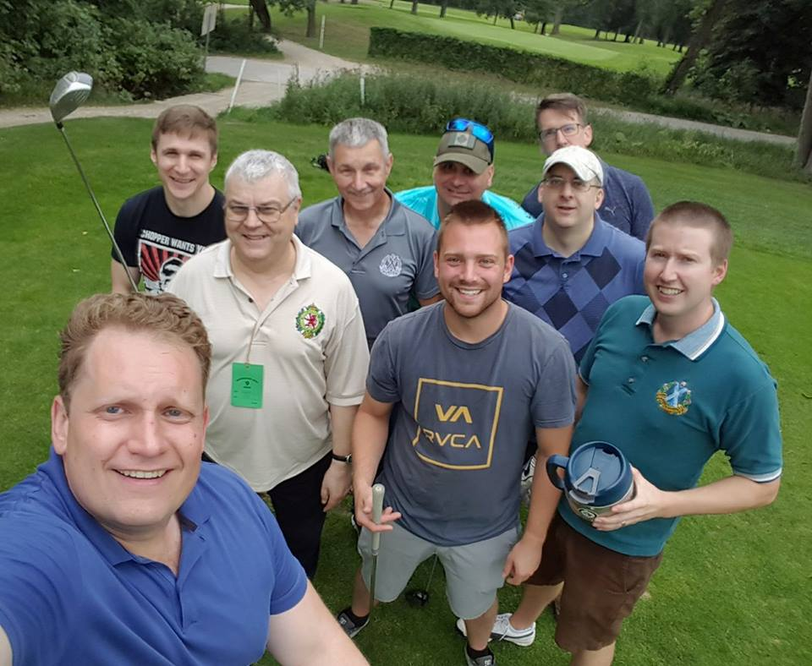
RE: BBC article “Appeal for relatives of WW1 Victoria Cross hero from Ayr”
http://www.bbc.com/news/uk-scotland-glasgow-west-41766808
Some of you will of course have seen the BBC assisted search for relatives of our V.C. winner Lt. (later LCol) Robert Shankland, V.C., D.C.M. by the South Ayrshire Council and wondered if they were able to locate any surviving family. It is my happy duty to report that although the regiment was not invited for whatever reason, LCol Shankland's granddaughter Janet Shankland-Huggins was able to attend on behalf of the family.
As you can plainly see she was proudly sporting our tartan and doing her best to let people know what regiment he ACTUALLY served with. She also tells us that the family still follows Cameron doings as best they can.
Robert Shankland VC, DCM
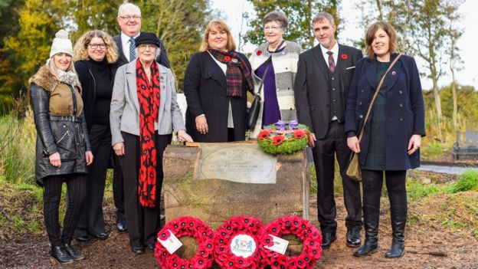
Hello,
My name is Janet Shankland-Huggins, I am the youngest Granddaughter of Robert Shankland.
My family wanted to let you know about a 100th Anniversary ceremony being held in his home town in Scotland on October 26th. I will be going to represent his family but I don't know if there is anyone to represent his regiment. We received the notification through distant relatives.
www.bbc.com/news/uk-scotland-glasgow-west-41502823
“...a paving stone in Mr Shankland's honour is to be unveiled in Ayr's Rozelle Park.
The ceremony on Thursday 26 October is part of the government-backed programme of recognition for World War One VC recipients in their home communities across the country.”
We thought his regiment should know about it.
Sincerely
Janet Shankland-Huggins
From: "Richard Kidd" <rakidd@shaw.ca>
Date: Wed, 23 Aug 2017
Subject: Request for information about a QOC Dieppe casualty
Hello,
I doubt that you can help me, but I was hoping your records might contain some information about a Queen’s Own Cameron Highlander killed in the Dieppe raid of August 19, 1942. His name was Lt. Richard Ambrose Wise. “Amby,” as he was called by his friends, was a close
friend of my father’s, and in fact I was named after him. My name is Richard Ambrose Kidd.
I was born on April 2, 1941. I believe I met my namesake once, probably in the summer of 1941, before he left for overseas, though of course I don’t remember the occasion. My only
proof of it is an old photograph.
I’ve managed to obtain some sketchy information about Lt. Wise from the Canadian Virtual War Memorial on the internet. He was born on December 1, 1910, in Winnipeg, the son of H.A. and Amelia Wise of Winnipeg. He was married to a Jean Wise, also of Winnipeg, and had a
baby daughter whose name I do not know.
My mother, who is now almost 97, remembers him well but can give me very little information about what happened to his family. She recalls correctly that his wife’s name was Jean, but can’t remember the daughter’s name. She does remember that the daughter was a year or two older than me, so she must have been born in 1939 or thereabouts. She also remembers that Jean
and her daughter moved east, probably to Toronto, after Dieppe, or perhaps after the war itself – she’s not sure.
It’s remotely possible that your regimental records might contain some snippets of information beyond the few that I know. I am particularly interested in learning the name of Lt. Wise’s daughter. Although his wife Jean must surely have passed on by now, the daughter – if still alive – would be only in her late seventies, just a year or two older than me. She’s in the photo I mentioned, perhaps two years old, along with me as a baby. It’s a long shot, I know, but
maybe – just maybe – your records might include the daughter’s name.
I doubt I’ll ever succeed in tracking her down, but I’m going to continue trying. I have in my possession a letter written from England to my parents in early August, 1942, just shortly before his untimely and tragic death. It may well have been the last letter he ever wrote, and it contains some poignant thoughts that might be of interest to his daughter, even though she never really knew him. I would like to share it with her, if I can ever locate her. I hope you can help, even
if only a little.
Yours sincerely,
Richard Kidd
683 Ash St.
Winnipeg, MB
rakidd@shaw.ca
Follow up email re: Request for information about a QOC Dieppe casualty
08/26/2017
Hello Hugh,
Thanks very much for your kind reply. I have a Winnipeg library card and will try searching the Henderson directories, as you suggest. I'll also take a look at "Whatever Men Dare" by Queen-Hughes.
I managed to find a section on the internet, in the Canadian Virtual War Memorial website, about Lt. R.A. Wise. I've learned his birthdate (Dec. 1, 1910), place of birth (Winnipeg), the names of his parents (H.A. and Amelia Wise), and the date on which he enlisted in the army (Aug. 1, 1940), and I've confirmed that his wife's name was indeed Jean. There was no
information there about his daughter, unfortunately. The website also contained a reproduction of a short article from the Winnipeg Free Press, undated but obviously from August, 1942, which shows a photograph of Lt. Wise.
It's possible that one or two Dieppe survivors might remember Lt. Wise, but they would all be in their late nineties now, and it stands to reason that their memories are fading. I would certainly appreciate your publishing my letter in your newsletter, as that might trigger some responses. I would appreciate hearing from anyone who served with my namesake, either here in Canada or overseas.
Thanks again for your help. If I can come up with some more information, I'll gladly pass it along to you.
Sincerely,
Richard Kidd
* Where Are They Now ? *
Steve anema (Cold war, former CO and Comd 38 CBG) was in for the 2017 Reunion and Golf BBQ. He\s looking to be in top form and still as interested in the Camerons as ever. Thanks for dropping by Steve !
Andre blais (Cold War) - Had a lovely 32 day trip to Italy. Sunny, Hot and Humid. Can't kick over a rock without finding a Roman ruin. Had a lot of fun driving in the Italian Alps. Roads a bit narrow in places and no guard rails so you don't want to drive to far to the right! Quite amazing where the WWI front was. still cannot figure out how the Italians managed to lose such imposing front lines. The 16" shells might have shaken them up a bit. Anyways it does add to how remarkable Rommel did there. A lot of uphill work. Around here it has been the worst for fires. almost the whole summer we have been under a blanket of smoke. It cleared for a couple of days then socked in again. I would move to Arizona if it was Canadian.
GLENN FEDORUK (Cold War, RSM Calgary Higlanders) – This August Glenn got to go over to France for the unveiling of the HILL 70 Monument as well as to “be part of a burial ceremony to put to rest SGT Milne, Calg Highrs and an unknown soldier , MIA since WW1. This is a true honour.”
We all agree – what an honour Glenn !!!
STEVE HILL (Cold War) – Dave Gibson got a call from Steve Hill a little while ago. He is living in BC, but was in Winnipeg for a couple of weeks for work. I don't know how many others missed him but Hugh did and hopes Steve will try again next tim ehe's in town for a bit. Thanks Dave !
Lloyd Jones (SWW) Hugh spoke to Lloyd on 04 Nov. At 95 Lloyd is his being usual “idle” self, out raising all kinds of dollars for his Legion's Poppy Fund every day, lining up as MC at his local RCL Branch 11 Nov service, helping out at the Shrine, speaking to schools and interested groups about the meaning of Remembrance Day and what it was like during his war. And then there's his activities in support of the local Phoenix Food and Drug Rehab Program...
Sadly I must report that his Lady is not doing too well. Please keep them in your thoughts.
Roy MacGillivray (RCR SAS PL 1948, Cameron RSS 1970's) is doing OK. Hugh and Roy had a good chat just before Roy's latest birthday (26 Aug 2017) have tried on a few occasions to link up for a coffee but so far Roy keeps having to go for a visit to the MIR for something or other. No worries Roy, we'll get together yet !
Vi Miller (Russ’s widow) - Vi is doing well and enjoying life.
Paul Nemez (SWW) Hugh tried to get in touch with Paul in but no dice. Hugh plans to try yet again very soon. If any of Paul's family are watching this column I hope that they spot the book launch for Canadian military history author Mark Zuehlke's new book about the post Normandy fighting. There should be a decent sized bit about some of the fighting that Paul told Hugh about during his last visit.
Bill Naven (SWW, Post War) Nothing new from Bill lately. Hugh called on 26 Oct 2017.
Ken Smith (SWW) Hugh and Ken have had a few good chats lately and one not so good one following Donny Morrison's passing. Ken is doing ell and sends his greeting to all ranks serving and retired of the Camerons ! God bless and cheers back at you from all of us Ken !
Ken still visits regularly with fellow Legion of Honour recipient Piper Bill MacKay at George Derby Home. Bill is also doing ok but isn't up to much travel these days.
No Stone Left Alone Memorial Foundation
https://www.facebook.com/NoStoneLeftAlone/photos/pcb.1631687426862047/1631687393528717/?type=3&theater
Following several months of intensive work between volunteers in Canada and Poland, we have staged our inaugural international No Stone Left Alone (NSLA) commemorative ceremony in Kraków. The ceremony at Kraków's cemetery, where 15 Royal Canadian Air Force WW2 pilots are buried, was a collaborative effort between Polish students, scouts, educators, parents, city administrators, Polish 6th Airborne Division, retired Polish military pilots and Poland's ministry of foreign affairs; combined with the leadership and staff of our Canadian embassy in Warsaw, Canadian forces, and dedicated NSLA volunteers. Together, we have ensured that from now on, headstones of fallen Canadian soldiers in Poland, will be annually commemorated with poppies and a fitting ceremony. More importantly, perhaps, by formally twinning Polish schools with Canadian headstones, we have assured that future generations of youth will be learning about our soldiers' role in WW2 and the ultimate sacrifice that they have paid in pursuit of peace in Europe.
A big thank you goes out to all our partners and supporter for bringing this project to fruition. Students, Principal, Teachers and parents from School #58 in Kraków worked throughout summer, learning our Canadian anthem, poetry in English, and organizing the event. Canadian Embassy and Military Attaché in Warsaw coordinated protocols with Polish armed forces and government. Maureen and Randall Purvis coordinated this undertaking.
Into the future, No Stone Left Alone Memorial Foundation is committed to continue its work wherever Canadian fallen soldiers' headstones are left alone.
Please, support our effort. Your donations can be made at.
http://www.nostoneleftalone.ca/

* 2017-18 Dues ($20) STILL Payable until AUG 2018 *
As of any old time you can connect with Association Treasurer David Gibson (per the cover page of the Oatmeal Rag) who will take your payment. If you are not sure of your status please contact Dave and he’ll either be happy to take your $20.00 payment or be most unhappy that he doesn’t get to take any money from you - yet - this year.
A newer method that can also be used is interact e transfer. Our Treasurer, Dave Gibson has now gotten set up for it, but you can also do it through the Secretary, Hugh O’Donnell. It works rather like pay Pal for those of you familiar with that service. Here’s link to one of the the web page options:
http://interac.ca/en/interac-e-transfer-consumer.html

* Cameron Association REPORT *

*** Reminder you too can become a LIFE MEMBER of The Association ***
This was an item added to the agenda at the last AGM by some very forward thinking members of the Association. It would be beyond rude to comment upon their age however I must point out that this is yet another case of our elders and betters displaying flexible thinking. Fossilized they are not !
Short version, any member in good standing of at least 65 years of age will be allowed to buy a Life Membership in the Cameron Association in Canada for $250 Cdn as of NOW. This money is restricted to being spent on an “as earned” basis, which is to say The Association cannot have a grand party one year and be broke the next. We can only add the $20 per year of the $250 to each succeeding year's budget.
The Cameron Fallen Comrades Memorial – LAUNCHED, QUOTE RECEIVED
This project has kicked off. It is not a short term project and will require some very serious fundraising efforts. The best guesstimate on costs right now (29 October 2017) is that this monument at today’s prices will run about $200,000, plus or minus a bit.
Points to take to heart are:
Previous generations of Camerons have wanted any money spent to benefit the living not the dead, so to speak. There are very few living “Wartime” Camerons now. All of our First War men and most of our Second War men are gone. Our “Peacetime” (Cold War, PKO’s, etc) Camerons are mostly looked after one way or the other but none that we are aware of are in actual need of anything other than the odd visit. Our Afghanistan veterans are mostly looked after, or at least the Association is not aware of any in need – but for God’s sake let us know if we’re missing someone !
Previous generations of Camerons were for the most part working men, not rich men, and have always wanted any memorials to our dead to be sited here in Canada where their children and grandchildren could actually have a chance of visiting them. Before we contemplated building anything on foreign soil (despite very worthy requests from other agencies in places like Dieppe and Normandy) we have looked for a place here in Winnipeg where our “Cameron Regimental Home” is sited. A place in Winnipeg’s Vimy Ridge Park has recently been offered by the City of Winnipeg for just such a monument.
No small number of our dead were single men. They have no family left to remember them, no grandchildren to honour their memory. Their names are not recorded anywhere in the public eye except the odd school Roll of Honour; or perhaps on a plaque “To Our Fallen” in some ghost town’s collapsing kirk like the one Greg Graham rescued at Ardath, SK last year. They are only names on headstones in faraway places. Surely we can do better than that by our own.
The time to honour the Cameron dead of The Somme, Passchendaele, Amiens, Dieppe, Normandy, The Scheldt, and other lesser known hells with more than words and stern faces once a year has come. This is going to be a long grind. The Camerons with connections to money should try to help out and every dollar raised will be needed.
If you call yourself a Cameron be a part of it. They deserve no less.
Donations may be made to:
The Queen’s Own Cameron Highlanders of Canada Regimental Foundation
Minto Armoury, 969 St. Matthews Avenue
Wpg, MB R3G 0J7
Donations of more than $25 will be issued a tax receipt.
Last Post Fund Update - Repeat
Yes, your editor did in fact mean the term in the sense that the Royal Canadain Artillery use. He did so because this information is definitely worth repeating. For those of you who still have never heard of this program here are the basics:
The Funeral and Burial Program - The Veterans Affairs Canada Funeral and Burial Program ensures that eligible Veterans receive dignified funeral and burial services. The Program is administered by the Last Post Fund, a non-profit organization that has served Veterans since 1909. Per the visit from LCol (Ret'd) Ken Sabatier and two other reps of the local Last Post Fund at our meeting on 05 June 2017, there have been several important changes to who qualifies for the program !
While I will briefly lay out some of the changes here the full details are available at their web site: http://www.lastpostfund.ca/EN/funeral.php
“In the case of a Veteran with a spouse or dependent children (or both), the combined assets of the couple are considered, excluding the family house, one vehicle and income received during the month of death. All liabilities, including funeral and burial costs, are then deducted. To qualify, their combined net asset value must be $35,279 (raised from $12,015 on October 1st 2016) or less.
In the case of a single Veteran, if the net value of the estate is not sufficient to pay off all existing liabilities, including the cost of funeral and burial services, the Veteran is deemed to be eligible for assistance. “
As with any government program there is a lot more to it than that – but at least now you have a starting point should you know someone in such a predicament.
* Regimental Web Sites *
The Unit web site is still up running. The unit web site continues to be a point of contact between ourselves, the families of those who served in the Camerons, and those who become interested in the Camerons for one reason or another. We continue to have a few requests through the unit web site for information from families about former Camerons. If anybody can help out with them please feel free to do so. You can find the web site at:
http://thequeensowncameronhighlandersofcanada.net/
Our Picasaweb site is gone but ALL of the pictures were carefully stored by the Google staff and exist in a new file on Google Photo. The down side is that this new file is accessible only to Hugh at this time. He is still working as time permits to get this information posted again and will post the new link here once it's functional again.
The Cameron Highlanders of Canada Memorial Site, Recording the History of the Regiment, 1914-1919, web site is one that every Cameron should have a look at once during the 100th Anniversary of the Great War. The creator of this site, Mr. J. Stuart McLean has done a great job of helping out the Cameron regimental family. Thanks for sharing your hard work sir !
http://www.cameronhighlanderscanada.com
Wilfred Laurier University has a page devoted to the Canadian War Diaries of the Normandy Campaign. While not a complete collection at this time (The Fort Garry Horse are missing as are some of the supporting arms and services War Diaries), ours and the rest of the 6th Brigade look to be complete.
http://lmharchive.ca/canadian-divisions-of-the-normandy-campaign/2nd-canadian-infantry-division/
51st Highland Battalion (7 SCOTS)
http://www.army.mod.uk/infantry/regiments/26345.aspx
51st Highland, 7th Battalion The Royal Regiment of Scotland (7 SCOTS) is the Army Reserve (formerly the Territorial Army) Infantry Battalion for the North of Scotland. The Infantry Mission is 'To defeat the enemy through close combat.' The Battalion Headquarters (BHQ) is in Perth and there are Company (Coy) and Platoon (Pl) locations at Army Reserve Centres in Dundee, Aberdeen, Kirkcaldy, Inverness, Elgin, Stornoway, Dumbarton and Stirling. Our paired Regular Battalion is The Black Watch, 3rd Battalion The Royal Regiment of Scotland (3 SCOTS) based at Fort George near Inverness and we form part of 51 Infantry Brigade.
For most of us, the Army Reserve is a second job, but as Reservists we have a real job to carry out, and there are Officers and Soldiers serving on operations wherever the Regular Army is deployed. We are resourced and equipped to the same levels as the rest of the Army and are trained to the very highest standards. In recent years a large number of our Officers and Soldiers have deployed to Bosnia, Kosovo, Iraq, Afghanistan and Cyprus alongside our Regular SCOTS counterparts.
We are a light role Infantry Battalion. This means that we have little reliance on vehicles. Instead, and in the finest traditions of the Infantry, we carry all of the kit and equipment that we require in order to live and fight. We pride ourselves on our physical fitness and our mental and physical resilience and robustness.
Sport and adventure training also play an important part in life at 7 SCOTS. Fitness, leadership, teamwork, courage and self reliance are developed through a rigorous programme of sport and adventurous training. We regularly play sport and conduct a number of adventure training activities both in the UK and when conducting overseas training exercises.
* Unit Events *
Regiment: The regiment as a whole is preparing for Remembrance Day. The battalion and cadets will mostly be at Minto, the Association and Advisory Board members across Canada are planning a moment somewhere suitable.
The Winnipeg Infantry Tactical Group Christmas Dinner will be on 09 Dec 2017 at Minto Armouries on the Parade Square as usual.
Details will be posted in the next Oatmeal Rag regarding the 2018 Cameron Kirk Parade.
Battalion: The Unit has made it through the period of fiscal restraint and is carrying on with the usual Training Cycle now. The battalion has also had troops away on various operations and tasks as is the norm these days.
On the 20th of October this year the Officer's Mess, with assistance from the Advisory Board and Association, carried out the annual Officer's Mess Dinner. This annual event commemorates the awarding of the Victoria Cross to the then Lt. Robert Shankland, D.C.M. For his actions on the 26th of October 1917 at the Bellevue Spur during The Battle of Passchendaele.

Cams of C Camerons on OP LENTUS 17 (B.C. fire fighting)
Camerons in the Arctic. Rankin Inlet, Op Nanook 17
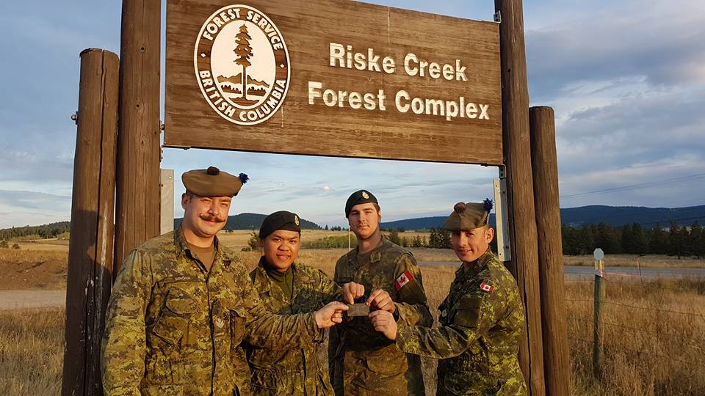
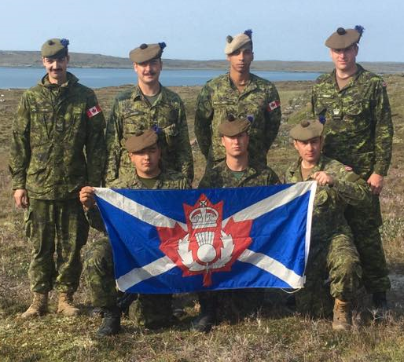
Pipes & Drums Update: The Pipes & Drums have had an active summer with several members away on tasking to the Ceremonial Guard in Ottawa. The band also performed at the Regimental Reunion and was the final act on the closing night of Folklorama’s Scottish Pavilion.
Pipe-Major Dan Locke
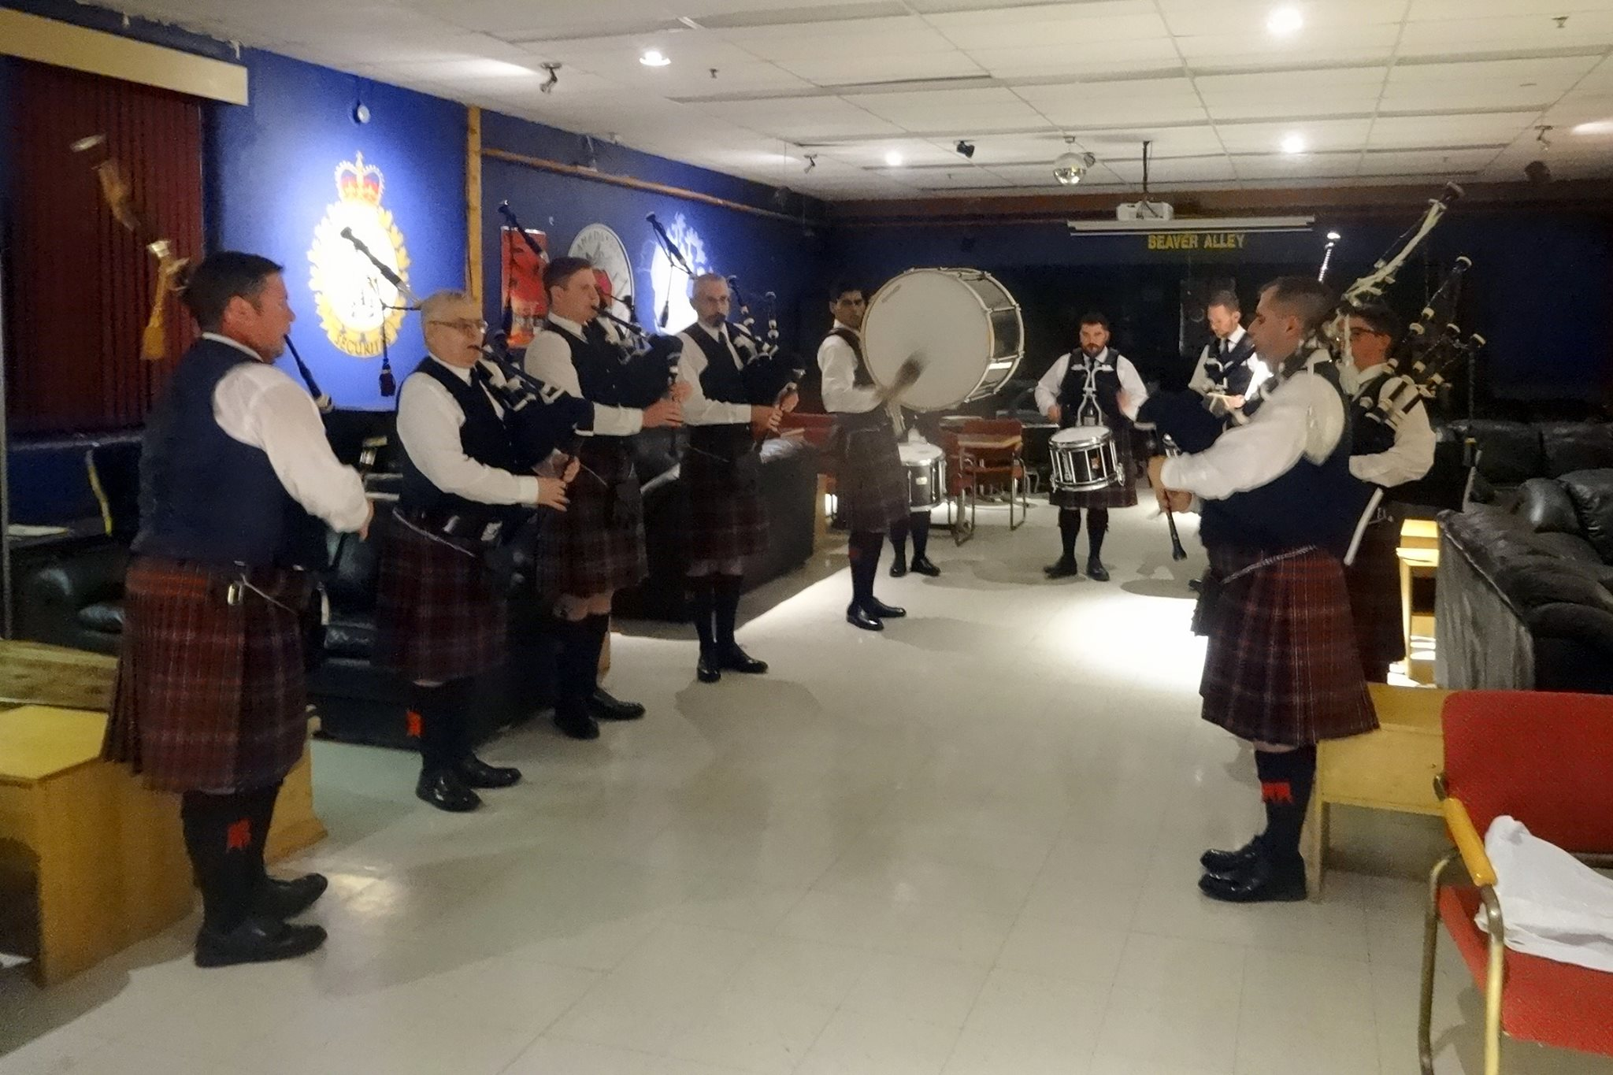
Sergeant
The Queen's Own Cameron Highlanders of Canada
Winnipeg Infantry Tactical Group

The Cameron Pipes and Drums playing at the Cameron Reunion 2017
The “new” uniforms that they're sporting are far more suitable to reunion weather
than the old woolen scarlets and so on I'm told.

2017 Sgt-Maj Wayne Nicholson Memorial March and Shoot Competition
Cpl Larsson, Cpl Hugill and Pte Janzen won the Wayne Nicholson Memorial March and Shoot Competition. Well done lads !
“A” Company Update: The Company has kept busy since the stand to in September with the Battle Fitness Test and two successful Collective Training weekends. Troops have returned safely from assisting in fighting fires in British Columbia for Op Lentus. We are now in preparation for the third Collective Training weekend coming up in the end of October.
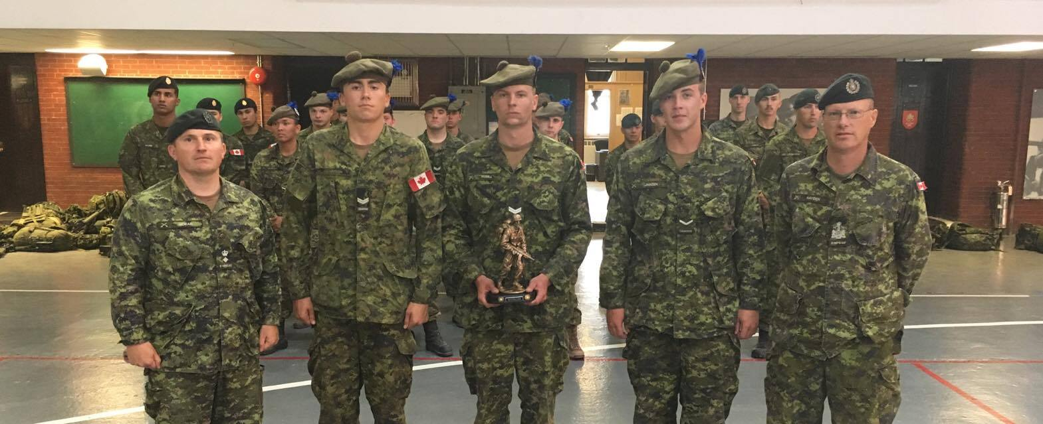
Cameron Bonnett
Ocdt
A Coy Admin O
Winnipeg Infantry Tactical Group (Rifles and Camerons)
Editor's note: For all of you Cold War Camerons – YES, this is one of our pal Rob's boys. The family link is quite apparent but he hasn't managed to follow all of his father's footsteps just yet. Give him time...
The CT weekends mentioned include the now usual pairs fire and movement Live ranges. The Primary Reserve has come a long way from the old days with only the odd Live fire at Shilo on the Training Plan during the winter months. Weird but true – the Army got something right !
Cameron Kit Shop: Capt Warsza has retired after many long years of quietly looking after us. Thank you very much sir, you will be greatly missed ! MCpl Mike Knudson from the Rifles is our new contact in the combined Kit Shop and the list of goodies will be emailed to anyone who requests a copy from the Editor of the Oatmeal Rag, Hugh O'Donnell
That's all for now. Ullamh!

* Regimental Advisory Board Notes *
The Advisory Board continues to provide sound advice to the CO on all matters Cameron in “interesting times”. The Board also continues to try to support all ranks and the Cameron cadets in their various endeavours.
In particular of late they have been supporting the writing and publication of what should prove to be THE new standard work of pipe music for not only our own pipes and drums – but many more pipe bands too. The Advisory Board are also active behind the scenes helping the Cameron Association to move forward with the Monument project.
Editor's note: I'll leave it for a certain Josh Fordham and Dan Locke to provide more details as they so desire but having heard some of the music to be included - to say nothing of the names of some of the composers of said tunes - I can't help but agree with them !

* Regimental Foundation 2016-17 Notes *
The Regimental Foundation still has several projects up for consideration again, one of which is the memorial to our Fallen Comrades. Thank you to all of those who have contributed to the Foundation. Every dollar helps !
On behalf of those who really enjoy The Oatmeal Rag, here is a big thank you to all those of you who have donated to the Foundation over the years. It has been well spent on various projects including this newsletter and is very much appreciated !

* Cameron Cadets *
The Cameron Cadets are off to a great start this year. We are parading in the min 50’s on a regular basis. Our effective strength is in the mid 70’s. The cadets have just completed out first Biv exercise of the year in which we had 46 cadets out. The cadets worked on camp routine and shelter building for the weekend. The Cadets are buy preparing for our duties surrounding Remembrance day. Our cadets will be assisting the Norwood Legion and Fort Garry Legion this year with their Poppy Drive, as well as attend the Service at the Norwood Legion. If you know of any youth between 12 and 18 years old who may be interested in cadets please have them either call the office at 204-786-1130 or come down and see us Thursday evenings from 1830-2100hrs.
Andrew Flook
(Not Tim, right Hugh ?)
For further information regarding our cadets please visit their official web page and you will see how to sign up for REMIND. This will be a communications tool the Corps uses to notify all concerned of activities, notices, quick information etc.... sign up at: http://www.407army.ca/
* Regimental Reinforcements *
Nil this time out.
* OTHER Regimental NOTEs *
Rounds Completed:
DIEPPE RAID 75th ANNIVERSARY
The Battalion was able to send a group of soldiers to participate in the commemoration ceremonies in France as usual. Hopefully some of the lads in the Guard will pass along their story at some point but we have one for you that definitely deserves mention - Pipe-Major John Dawson was able to perform a very special tribute to Pipe Major Graham:
“I made my way to Green Beach - 75 years later, and played "A hundred Pipers" in the minutes leading a up the exact time that the Regiment landed on that fateful day. It was a privilege to do so.”
LCol (Ret'd) Sandy Will, our Cameron representative with the Canada Remembers program in France this year, told us that he had quite a trip. As mentioned the Voxair, 17 Wing Wpg's Base Newsletter did an article about the Raid. Maj. Ken Smith and John Johnson and possibly a few others out there got calls from their staff writer Martin Zeilig. See page 5 of the August 2017 Issue of The Voxair to read it for yourself:
http://www.thevoxair.ca/Issues/2017/Web Voxair Issue 15 2017.pdf#The Voxair August 2017 Issue
Annual Cameron Reunion
As previously announced this year the Annual Reunion took place on the same weekend as the Cameron Stand To. This move was not without regrets but is absolutely necessary for the future health of the Association. Thanks to some very strong encouragement from the serving members of the battalion we had at least 11 young Camerons join us not only for the reunion in the Mess but on the links too ! Thanks for coming out lads but do try to remember that your tee shot should probably not be aimed into Sgt-Maj Clark's face or golf cart. That can have bad long term results.
Incoming Rounds:
Stay tuned to the Cameron web page, Facebook page, and check your email every now and then too. The new Executive will be meeting soon to plan a few fun events again this year. So far the plan includes another round of racing at Speedworld. Pass your ideas our way and we'll see if we can make them happen.
The 58th Cameron WO's & Sgt's Robbie Burns Supper on 20 Jan 2018 will be at the usual venue, The Fort Garry Hotel. The cost is a quite reasonable $85/head for an event of such quality. Tickets are available from your favourite, or least favourite, Cameron WO or Sgt.
And just because it's 2017 and not 1917 you can pay by Interac transfer to:
qochwoandsgtclub@gmail.com
Kirk Parade in February DTG is yet TBC.
* Links *
Before You Go - Information for Reservists to assist their Release from the Canadian Armed Forces
This site is set up for guys like us. The P Res guys who are trying to figure out just what in the heck is supposed to happen. It is available to guys who are already releasing, are long out, etc.
http://www.forces.gc.ca/en/caf-community-support-services-for-members-reservists/before-you-go.page
New generation of vets more welcome at Veterans' Health Centres
The Perley Rideau Veterans' Health Centre is now welcoming a new generation of veterans.
Up until now, the federal government's strict criteria only allowed men and women who were veterans of the Second World War and the Korean War to move into the veterans side of the long term care facility —and many others across the country.
The rules have begun to change, and a limited number of beds are opening up to peacekeepers and other retired Canadian Forces members. They can now apply to live and receive care with other former soldiers and officers.
http://www.cbc.ca/news/canada/ottawa/perley-rideau-modern-veterans-1.4040703
Missing Soldiers in the Netherlands
https://www.arnhem1944themissingones.com/the-work-of-the-war-graves-concentration-registration-units/construction-of-the-dutch-war-cemeteries/
This site started out as a “website about the Battle of Arnhem missing as some 412 men who fought at Arnhem in September 1944 are missing since.
However is the progress another topic was added: "Non-Arnhem missing" about Allied and German (alliance) soldiers missing in the Netherlands in the period 1940-1945, however please keep in mind that some parts are still under construction.
Throughout this website, I would like to try to give them a face and a name. “
Registered Disability Savings plan (RDSP)
https://www.canada.ca/en/revenue-agency/services/tax/individuals/topics/registered-disability-savings-plan-rdsp.html
If you have left the military with a disability that qualifies you may wish to look into this plan.
U.S. Army unprepared to deal with Russia in Europe
http://www.politico.com/story/2017/09/02/army-study-173rd-airborne-brigade-europe-russia-242273?cmpid=sf
A self-assessment by the 173rd Airborne Brigade is called ‘a real eye-opener’ to how some critical capabilities to deter Russia have eroded.
“The common thread running through the paper is the challenge posed by Russia’s jammers and other electronic warfare tools.
An enemy equipped with these “could effectively neutralize a GPS system from 50 miles away using one-fifth the power of a tactical radio,” the report estimates, so “we should assume that GPS will be either unavailable or unreliable for the duration of the conflict if the [brigade] faces a near-peer threat or sophisticated non-state actors.” “
Editor’s note: It might be for the best to keep up those old steam powered map and compass lectures lads.
A Guide to Russia’s High Tech Tool Box for Subverting US Democracy
https://www.wired.com/story/a-guide-to-russias-high-tech-tool-box-for-subverting-us-democracy?mbid=social_fb
“According to interviews with more than a dozen US and European intelligence officials and diplomats, Russian active measures represent perhaps the biggest challenge to the Western order since the fall of the Berlin Wall. The consensus: Vladimir Putin, playing a poor hand economically and demographically at home, is seeking to destabilize the multilateral institutions, partnerships, and Western democracies that have kept the peace during the past seven decades.”
“The focus of applied methods of conflict has altered in the direction of the broad use of political, economic, informational, humanitarian, and other nonmilitary measures—applied in coordination with the protest potential of the population,” he wrote. These tools, he said, would be “supplemented by military means of a concealed character,” like special forces. Only in the final stage of a conflict would uniformed military be deployed, usually “under the guise of peacekeeping and crisis regulation.”
Do You Know Your AFV's of the World ?
Shoot or Don't Shoot has taken on a new imperative in today's Canadian Forces deployments. Gone are the days when anything Soviet-ish was pretty much an automatic “Shoot” response. The old sweats out there of our Veteran's Guard (the term Old Guard being found “too French”) might think they need their eyes examined but this is our young soldier's reality.
https://www.militarytimes.com/2016/03/06/the-pentagon-starts-planning-to-base-more-troops-in-europe/
LIGHT READING – OR NOT !
Canadian Corps Soldier vs Royal Bavarian Soldier
https://ospreypublishing.com/canadian-corps-soldier-vs-royal-bavarian-soldier
“In 1917 the soldiers of the Canadian Corps would prove themselves the equal of any fighting on the Western Front, while on the other side of the wire, the men of the Royal Bavarian Army won a distinguished reputation in combat. Employing the latest weapons and pioneering tactics, these two forces would clash in three notable encounters: the Canadian storming of Vimy Ridge, the back-and-forth engagement at Fresnoy and at the sodden, bloody battle of Passchendaele.
Featuring carefully chosen archive photographs and specially commissioned artwork, this study assesses these three hard-fought battles in 1917 on the Western Front, and offers a new take on the evolving nature of infantry combat in World War I.
Dr Stephen Bull is Curator of Military History and Archaeology for Lancashire Museums, with particular responsibility for local regimental collections, and is a consultant for the University of Oxford on World War I projects. He has previously worked at the National Army Museum and the BBC in London. Adam Hook studied graphic design, and began his work as an illustrator in 1983. He specializes in detailed historical reconstructions, and has illustrated Osprey titles on subjects as diverse as the Aztecs, the Ancient Greeks, Roman battle tactics, several 19th-century American subjects, the modern Chinese Army, and a number of books in the Fortress series.”
Editor's note: This is a short book with loads of the trademark high quality Osprey graphics AND a very detailed write up of the battle where Lt. Robert Shankland won his V.C. It also covers details of other Camerons who fought that day such as Capt Smart of our “A” Coy. Well worth the trip to McNally's in Winnipeg or Osprey online. Not sure who else carries it.
The Cinderella Campaign
http://www.douglas-mcintyre.com/book/the-cinderella-campaign
“This book is Canadian Military historian Mark Zuehlke's take on the First Canadian Army and the battles for the Channel Ports.
The story of how First Canadian Army opened the way to the Allied victory in World War II, in the twelfth installment of the bestselling Canadian Battle Series.
They thought of themselves as the "Cinderella Army," and international correspondents agreed. This was because First Canadian Army had been relegated to the left flank of the Allied advance toward Germany from the Normandy beaches and given the tough, thankless task of opening the Channel ports from Le Havre to Ostend in Belgium. Then suddenly in early September 1944, securing these ports became an Allied priority, as this would allow Field Marshal Montgomery to drive to the Rhine with Operation Market Garden and win the war before Christmas.
Given only scant access to the Allied supply chain, the Canadians and their British partners in I Corps tackled the task assigned. Just getting to the ports proved a terrific undertaking fought against brutal German resistance. And once there, they faced fortresses that had been prepared for years to defeat an attack. "Lost outposts," the Allies called them, but the Germans within were not going to give up easily. And so over the month of September, the Canadians set about fighting for control of each port, scrambling for supplies while under constant military pressure to get those ports open now. For Canada this was the Cinderella Campaign, the battle for the Channel ports. For those who fought it, the sacrifice of comrades dead and wounded would never be forgotten.”
Editor's note: Mark will be gracing us with his presence yet again at Minto Armoury on 12 Nov 2017. He will once again be ably supported by McNally Robinson and our CO has authorized the use of the Officer's Mess as a fitting location for this event. Mark mentioned that the Camerons feature prominently in some of the book's chapters. I'm not sure but I certainly hope that the experiences of Pte.'s George Pauls “on patrol” and Padre Davis made it into the book, to say nothing of the rest of the lads.
* Historical Notes *
There are still families of First and Second War Camerons asking for more information about their kin. If anyone can help out please send the Oatmeal Rag editor what you have or ask to be put in touch directly and he’ll do so.
Speaking of historical links, here's one that may prove useful to those looking for family or those trying to assist families searching for those who went of to the First World War:
https://militaryandfamilyhistory.blog/2016/04/18/nominal-rolls-of-the-canadian-expeditionary-force/
To quote this web page:
“A Nominal Roll is a list of the Officers, NCOs and Men who served in a unit of the CEF at a specific point in time. They were often compiled prior to a unit embarking for England and sometimes include embarkation information such as ship name, embarkation port and the date of sailing. A Nominal Roll usually lists a soldier’s Regimental Number, Rank, Name, Former Corps, Name of Next of Kin, Address of Next of Kin, Country of Birth, and both the place and date they were “Taken On Strength”.
It’s important to note that units experienced continual and sometimes significant changes to personnel. Major battles resulted in huge numbers of casualties but so did “wastage“, a term used to describe the daily toll of soldiers wounded or killed by sniping and shelling. The never-ending need for reinforcements meant that Nominal Rolls had a very short shelf life.”
Montreal marks 75th anniversary of Dieppe Raid by renaming park
http://www.cbc.ca/news/canada/montreal/dieppe-raid-montreal-75-years-1.4254232
Montreal's Parc de la Cité-du-Havre was renamed Dieppe Park in honour of the 75th anniversary of the Dieppe Raid, a deadly World War II battle that set a record for the number of Canadian soldiers killed in a single day.
Here are a some more interesting links for you courtesy of our “Cameron Association reporter” in Montreal Gordon Krip:
Hi Guys, I dug up a few local news items about the 75 the Anniversary. The 5 minute news interview with David O’Keefe is quite pragmatic. I also saw The Canadian History (Beaver) magazine by David, a bit harsh.
http://montreal.ctvnews.ca/video?clipId=1191127

http://montreal.ctvnews.ca/video?clipId=1191127

http://montreal.ctvnews.ca/video?clipId=1191127

http://montreal.ctvnews.ca/video?clipId=1191127

http://www.ctvnews.ca/canada/canadians-mark-75-years-since-dieppe-our-deadliest-second-world-war-battle-1.3552904

http://www.ctvnews.ca/canada/canadians-mark-75-years-since-dieppe-our-deadliest-second-world-war-battle-1.3552904

http://www.ctvnews.ca/canada/canadians-mark-75-years-since-dieppe-our-deadliest-second-world-war-battle-1.3552904

http://montreal.ctvnews.ca/video?binId=1.1810302
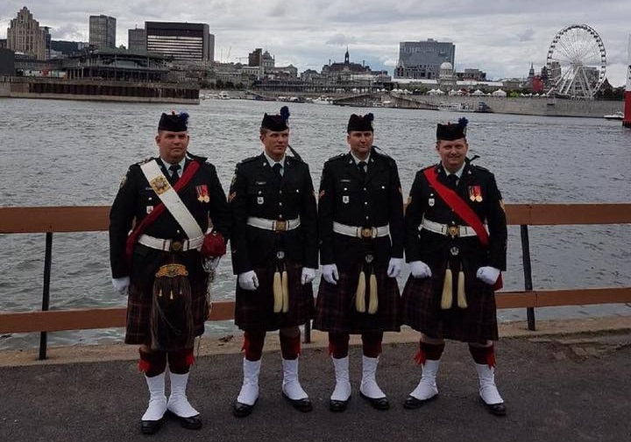
The Cameron contingent in Montreal

“It wouldn’t be an Oatmeal Rag without a Wee Joke” - Russ Miller
Verification of Former Service DS Solution: You can check the FAQ at this site for more information but here are the basics:
“28. I used to be a CAF member. How do I get my file?
Service records of retired or released CAF members are kept at DND for only a few years before they are sent to Library and Archives Canada. So if you recently retired or have recently been released from the CAF, and suspect your records might not yet be held at Library and Archives Canada, you may contact the DND Directorate of Military Careers Administration to obtain your records by dialling 1-866-240-6726. However, most military records may be obtained through Library and Archives Canada, including at the following Library and Archives sub-site:
http://www.collectionscanada.gc.ca/genealogy/index-e.html.
You may call Library and Archives by dialing 1-866-578-7777 for assistance. Library and Archives Canada is the federal government department that preserves and makes accessible the documentary heritage of Canada. It also serves as the continuing memory of the Government of Canada and its institutions. As such, Library and Archives Canada holds extensive collections of military records.”
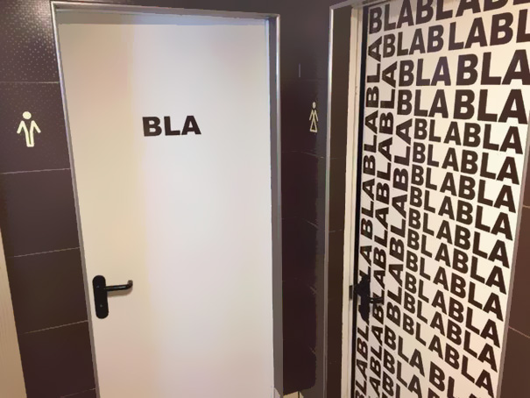

Veteran’s Transition Network
Editor's Note: I can't say that I know much about this program. Any comments ?
https://vtncanada.org/
https://vtncanada.org/resources/

Cameron Trophy – Manitoba Highland Dance Association
Association President Steve MacMillan was on hand this year to present the trophy to the winner, or should I say Third Time Winner Jennifer Watt ! It needs to be noted here that she will be going the the Nationals in Charlottetown this year where they hope to have up to 500 competitors.

Sponsorship
We are always seeking sponsors or advertisers to help defray the cost of this publication. If anyone is interested or has any suggestions as to whom to contact please let us know and we'll be happy to do the follow up.
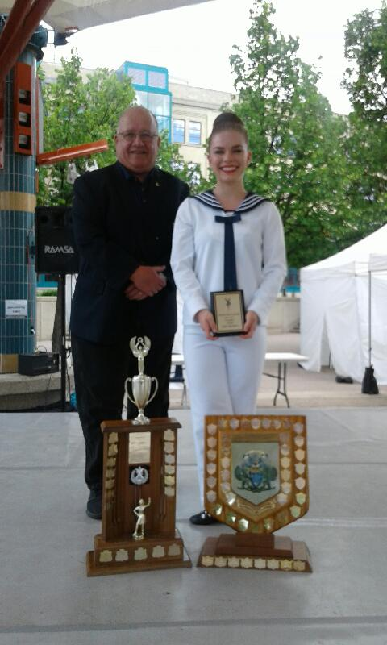
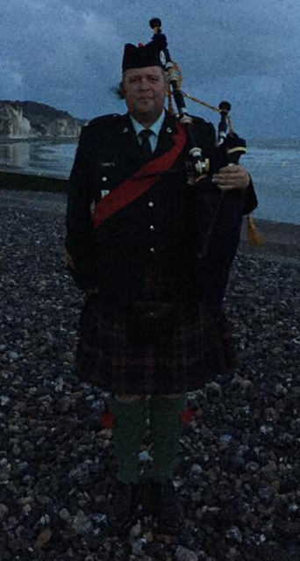
Sponsors to date are: Mr. Max Katz, our very first sponsor, of the Oatmeal Rag and the Jewish War Vets; Mr. Greg Flom, a former Cameron; Maj. Bill Gray, Cameron Advisory Board; Sgt Tim Seeley, Drum Sgt Extraordinaire; MCpl (Ret’d) Mark Silver, our “Eastern Branch” contact; Sgt (Ret’d) Roy Taylor, the Cameron WO’s & Sgt’s #1 choice for reading “Rab” Burn’s poetry; Maj. Ken Smith, who also has so kindly donated prizes for the Reunion Golf; Col. Bob Darling, Past President of the Cameron Advisory Board; Mr. W L (Lloyd) Jones, SWW Cameron; P/M Donald Morrison Cold War; Ken Smith and Lloyd Jones yet again God bless them; Sgt. Bill Douglas, Dieppe Raid.
Gentlemen, we thank you.
Our Sponsors for this issue of The Oatmeal Rag are the members named above and as always our special thanks to The Commissionaires for their continued support ! 
P/M John Dawson at Pourville, 2017

